SOAP UI testing for GPSOnline

# Import SOAP UI project

Click on File 🡪 Import project

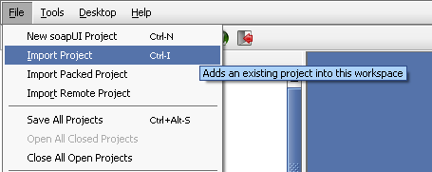

Browse and select the GPSOnline-soapui-project.xml

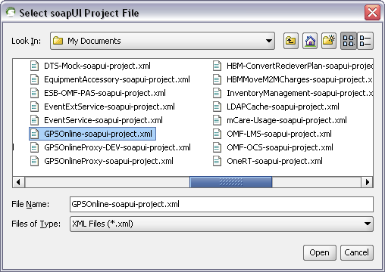

Once the import is complete, you will see the project of GPSOnline as below.

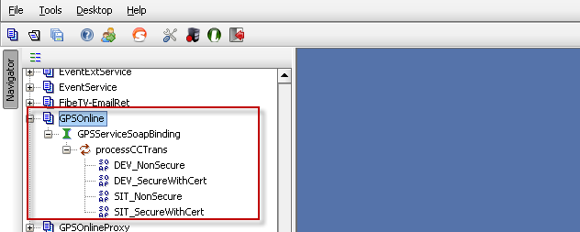

# Configuring Certificate/PKS file in SOAP UI

Go to File 🡪 preferences 🡪 SSL Settings

Browse and select the PKS file that will contain the required certificates for authentication. Input the password for the PKS file and click on OK.

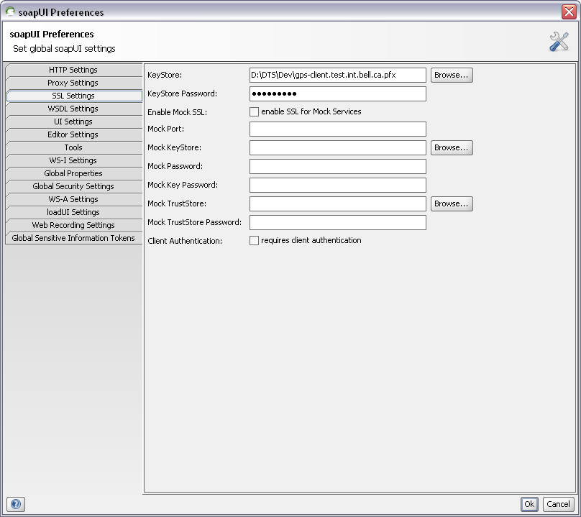

# Testing the service

Execute the service once you paste the request XML and on the right hand side you will be able to see the response XML.

## Testing with Certificate

To test the service with certificate, use the url that starts with https and once you receive the response, you will be able to see 3 certs in SSL Info section of SOAP UI as highlighted below which confirms that the certificate was sent to the system for authentication.

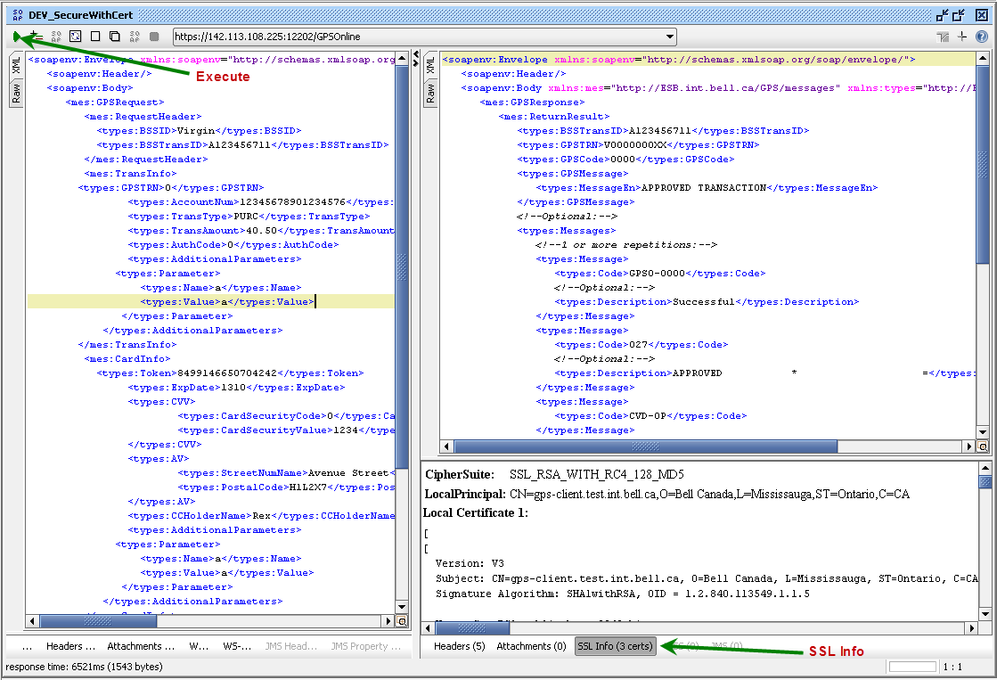

## Testing without certificate

To test the service without certificate, use the url that starts with http and once you receive the response, you should not see any certificate in SSL Info section of SOAP UI which confirms that the request was sent to a non-secure port of the system.

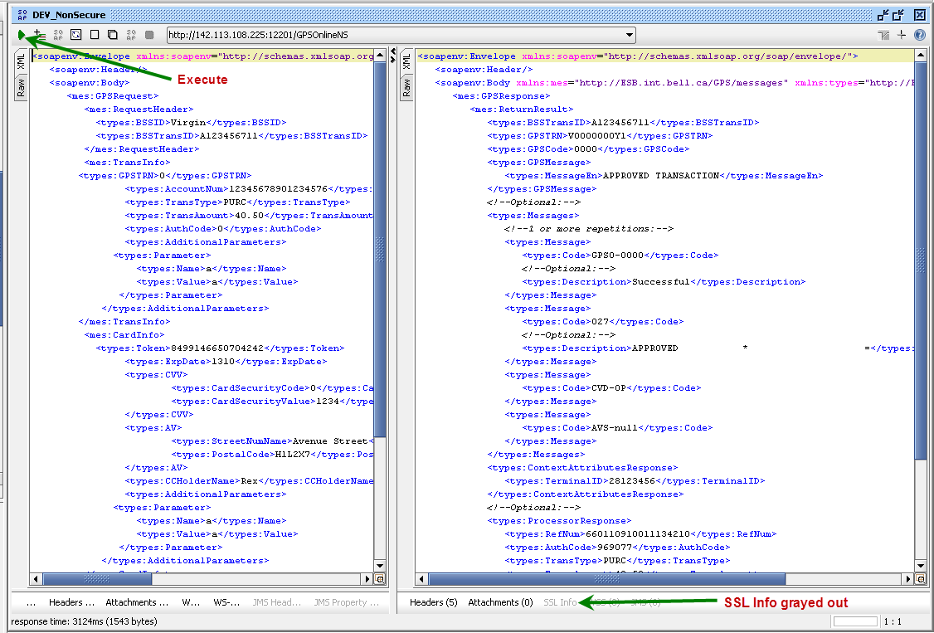

Attachments:



Password: gpsclient